Date: August 30, 2024

Attendance: Mike McDermott, Ryan Henry, Stephanie Welter, Jessica Minesinger, Judy Tomb

420 Rebekah Ct.

10am-10:52am

Jessica Minesinger is Judy’s daughter and she helps her with some of her business dealings. Now that Judy has bought a home in FL, Jessica may be the one “turning over” the HOA to the full Board in Nov/Dec.

Talked about an update to the date of invoice due from being ten days to an open amount of time. *- JM assigned to make edits.*

Declarations and Design Guidelines - allow vinyl fence, add 6’ fences, add metal roof for homes and sheds as long as the look is consistent with existing shingled homes/sheds. *- JM assigned to make edits*

Trash cans can be placed on a pad (cement or gravel) adjacent to the garage (not in front of). Only trash that fits within the trash cans can be stored outside. Furniture and large trash or boxes should be stored in the garage until trash day. *- JM assigned to make edits*

Talked about the improved condition of the dry basin. It appears to be draining properly. The combination of poor drainage and large rocks in the basin in the springtime made mowing difficult and impossible at times.

Confirmed with Judy that there are no individual owner ledgers of account, no late fees being charged, or assessments being made.

Delinquent HOA payments as of August 30, 2024:

35 delinquent for 2024

14 delinquent for 2023

5 delinquent for 2022

1 delinquent for 2021

**Total: $19,800**

Talked about the mowing and the lack of ingress/egress to some of the Common Areas. Currently the mowers have to pop a curb or “borrow” a resident’s lawn or driveway to access behind the homes to the East side of the property. Judy to request Ryan Homes to meet with us and discuss a possible curb cut or way to get back behind the homes more efficiently. We would like Robinhood/Dusty to be there for that walk-through. *- Judy to coordinate a future meeting with Ryan Homes*

Talked about introducing Eclipse Management into the mix to assist with the turnover process and turnover meeting as well as dues payments caught up. Judy preferred Eclipse be hired by the HOA AFTER the turnover. [Stephanie Welter](mailto:weltersl@gmail.com)brought up that it would be beneficial to bring Eclipse on board prior to turnover to assist with that. Per Section 2.4 of the Declaration:

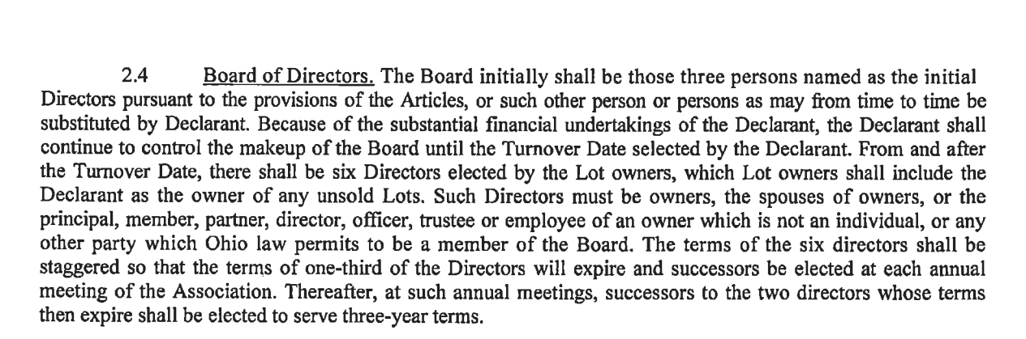

The Association is unable to be turned over to an “interim board” appointed by the Developer and needs to be turned over at a meeting of the owners that holds an election to appoint the new Board of 6 owners per the HOA’s Governing Documents.  *- JM and Judy to review governing documents and consider signing Eclipse contract and making the first monthly payment to them.*